Before I became strong, I knew what it was like to be weak.
How difficult it is to love yourself to find the wholeness that you seek.
Before I knew the light, I have had my fair share of darkness too, where my world fell into a hopelessness, and I didn't know how to get through.
For I have known the tears it takes, the courage to stand up again, when you are broken down and bruised, and you know nothing but the pain.
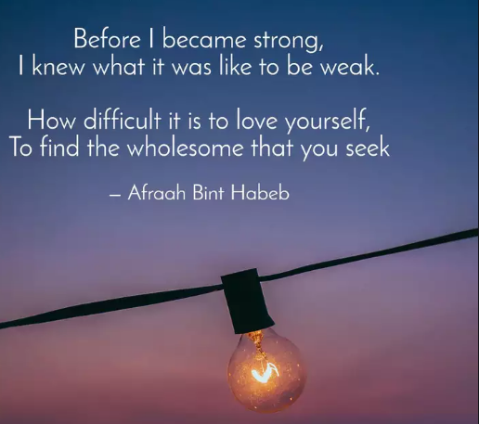
You forget to appreciate love,
if you haven't seen the hate, till you forget the meaning of smile and laughter, and your heart is left abate.
I have known the strength and courage, it requires to get it right, to face the things that hold you down, and hold your head up and fight.
Before I was who I am now, I was someone I didn't want to be.
I was lost, battered, and defeated, before I knew how to be me.
在懂得坚强之前，我清楚地知道什么是软弱。
也知道学会爱自己不容易，更知道生命的完整需要苦苦追寻。
在看到光明之前，我也曾游走于黑暗中，
生活暗淡无光，不知如何度过。
我知道，再次崛起需要多少勇气和眼泪，
当你濒临崩溃，伤痕累累，心中只有疼痛时。
你会忘了爱是什么滋味，
你会忘记欢声笑语，眼里只有恨意，逐渐迷失本心。
我知道，直面低谷，改过自新，重新昂首挺胸勇往直前，需要多大的勇气和力量。
在我找到自我之前，我是个陌生人，令人生厌。
直到终于找到了自己，才告别了伤痕累累，垂头丧气。

