扬州市2018-2019学年度第一学期期末检测试题
高三英语试题
本试卷分五部分。满分120分。考试时间120分钟。
第I卷（选择题,三部分,共75分）
第一部分 听力（共两节，每题1分，满分20分）
第一节 听下面5段对话，每段对话后有一个小题，从题中所给的A、B、C三个选项中选出最佳选项，并标在试卷的相应位置。听完每段对话后，你都有10秒钟的时间来回答有关小题和阅读下一小题。每段对话仅读一遍。
1. What will the woman do?
A. Make a call. B. Go to the park. C. Go out for dinner.
2. Where are the speakers probably?
A. At home. B. In a store. C. In a restaurant.
3. What does John think of Dr Smith’s speech?
A. Moving. B. Interesting. C. Disappointing.
4. Why did Tony move to a new apartment?
A. He didn’t like his neighbor.
B. He didn’t like holding parties.
C. He didn’t like his old apartment.
5. What’s the man going to do?
A. Read a book. B. Write a novel. C. Borrow a book.
第二节 听下面5段对话或独白。每段对话或独白后有几个小题，从题中所给的A、B、C三个选项中选出最佳选项，并标在试卷的相应位置。听每段对话或独白前，你将有5秒钟的时间阅读各个小题；听完后，各小题将给出5秒钟的作答时间，每段对话或独白读两遍。
听第6段材料，回答第6和第7题。
6. How often does the man go to the evening classes?
A. Twice a week. B. Three times a week. C. Four times a week.
7. Why does the man take the evening classes?
A. To go abroad. B. To make friends. C. To change his job.
听第7段材料，回答第8至第9题。
8. What’s the man?
A. A designer. B. A customer. C. A salesman.
9. How much is the necklace?
A. 200 dollars. B. 300 dollars. C. 400 dollars.
听第8段材料，回答第10至第12题。
10. How is Ted’s homework this time?
A. Very poor. B. Well done. C. So-so.
11. Where is Ted going now?
A. The gym. B. The library. C. The bookstore.
12. What is the relationship between the speakers?
A. Mother and son. B. Boss and secretary. C. Teacher and student.
听第9段材料，回答第13至第16题。
13. What’s wrong with the man?
A. He is out of work. B. He can’t find a job. C. He lacks support at work.
14. What is the man’s wife’s attitude toward his problem?
A. Optimistic. B. Worried. C. Careless.
15. Who is ill in hospital?
A. The man’s wife. B. The man’s father. C. The man’s father-in-law.
16. What does the woman promise to do?
A. Offer a job to the man.
B. Lend the man some money.
C. Ask her friends to help the man.
听第10段材料，回答第17至20题。
17. What is the monologue mainly about?
A. The history of the school.
B. The courses for the term.
C. The plan for the day.
18. Where can the visitors learn about the subjects for new students?
A. In the school hall. B. In the science lab. C. In the classroom.
19. What can students do in the practical areas?
A. Take science courses. B. Enjoy excellent meals. C. Attend workshops.
20. When are the visitors expected to ask questions?
A. During the lunch hour.
B. After the welcome speech.
C. Before the tour of the labs.
第二部分 英语知识运用(共两节，满分35分)
第一节 单项填空 (共15小题；每小题1分，满分15分)
1.It was nearly a week _______ the rescue team located the crashed plane.
A. since B. before
C. until D. after
【答案】B
【解析】
【详解】考查时间状语从句。A. since自从；B. before在……之前；C. until直到；D. after在……之后。句意：救援队花了将近一周的时间才找到坠毁的飞机。It is/was+一段时间+before表示“距某发生有……的时间”，故B项正确。
2._______ her before, he didn’t know she was his daughter.
A. Not having seen B. Having not seen
C. Not seeing D. Not to see
【答案】A
【解析】
【详解】考查非谓语动词。句意：由于以前没有见过她，他不知道她就是他的女儿。he与see之间是逻辑上的主谓关系，表示主动，而且see这个动作发生在didn’t know之前，应该用现在分词的完成式作原因状语，否定词放在最前面，故A项正确。
【点睛】本题非谓语表示的动作与谓语之间有明显的先后关系，see这个动作发生在didn’t know之前，应该用现在分词的完成式作原因状语，Not having seen=Because he hadn’t seen her before。
3.All children should get access to a high-quality education _______ their race, zip code or family income.
A. due to B. regardless of
C. apart from D. depending on
【答案】B
【解析】
【详解】考查介词短语辨析。A. due to由于；B. regardless of不管；C. apart from且不说；D. depending on根据。句意：所有的孩子都应该获得高质量的教育，无论他们的种族、居住地区和家庭收入如何。根据句意可知此处表示“无论、不管”，故B项正确。
4.Never _______ a greater, or more beautiful, or a calmer or nobler thing than you.
A. did I see B. have I seen
C. I saw D. I have seen
【答案】B
【解析】
【详解】考查时态和倒装。句意：我从未见过比你更伟大、更美丽、更冷静、更高贵的东西。Never位于句首时，要进行部分倒装，强调过去的动作对现在的影响要用现在完成时，故B项正确。
【点睛】倒装是高中英语的常见考点，注意当含有否定意义的词，如never，hardly，seldom，little，few，not until及not only等位于句首时，其后需要用部分倒装。
5.Some top American universities are accused of _______ Asian-American applicants using race as a factor.
A. deleting B. removing
C. denying D. restoring
【答案】C
【解析】
【详解】考查动词词义辨析。A. deleting删除；B. removing去除；C. denying否认；D. restoring恢复。句意：一些顶尖的美国学府被指控将种族作为一个因素拒绝亚裔美国人的申请。根据句意可知此处表示“拒绝、否认”，故C项正确。
6.The spokesman’s remarks help clarify an _______ statement issued earlier this week.
A. ambiguous B. ambitious
C. arbitrary D. authentic
【答案】A
【解析】
【详解】考查形容词词义辨析。A. ambiguous模糊不清的、模棱两可的；B. ambitious有野心的；C. arbitrary武断的；D. authentic真正的。句意：这位发言人的讲话有助于澄清这个星期早些时候发表的一份模棱两可的声明。根据“clarify”判断此处表示“模棱两可的”，故A项正确。
7.Students should involve themselves in community activities they can gain experience for growth.
A. who B. when C. which D. where
【答案】D
【解析】
试题分析：首先分析句子结构，可知这里含有一个定语从句，且关系词在定语从句中作地点状语，故用关系副词where，所以选D。句意：学生应该参加社团活动，在那里他们可以获得成长的经验。
【知识拓展】
被修饰的词叫先行词。定语从句不同于单词作定语的情况，它需要放在被修饰的词（即先行词）之后。定语从句一般由关系代词来引导。关系代词必须放在定语从句之首。定语从句在句中做定语，修饰一个名词或代词，被修饰的名词,词组或代词即先行词。定语从句通常出现在先行词之后，由关系词（关系代词或关系副词）引出。
考点：本题考查定语从句。
8.---Are you going to Tom’s birthday party?
---_______ I’ve got a present for him.
A. It depends. B. Don’t bother!
C. Are you kidding? D. Definitely!
【答案】D
【解析】
【详解】考查情景交际。A. It depends.看情况；B. Don’t bother!别麻烦了；Are you kidding?你在开玩笑吧？；D. Definitely!当然！句意：——你要去参加汤姆的生日聚会么？——当然！我为他准备了一份礼物！根据后面的“I’ve got a present for him.”可知这个人会去参加汤姆的生日聚会，故D项正确。
9.---I will have two final exams tomorrow.
---Me too. So you _______ any sympathy from me here.
A. aren’t getting B. didn’t get
C. aren’t going to get D. haven’t got
【答案】A
【解析】
【详解】考查时态。句意：——明天我有两科期末考试。——我也是，所以在我这里你得不到同情。语境表明第二个人明天也有两科期末考试，所以此刻不能给与同情，应该用现在进行时表示正在进行中的事情，故A项正确。
10.When you’re done, throw it all away and _______ your new assignment.
A. break into B. turn into
C. dive into D. fit into
【答案】C
【解析】
【详解】考查动词短语辨析。A. break into闯入；B. turn into变成；C. dive into钻研、投入；D. fit into符合、适应。句意：当你完成的时候，将它抛开，投入到你的新任务中去。根据句意可知此处表示“全心投入”，故C项正确。
11.I am impressed with China’s commitment to its climate goals, evidenced by the fact we are sure of ______ China has met its 2020 targets three years ahead of schedule.
A. that B. which
C. what D. where
【答案】A
【解析】
【详解】考查同位语从句。句意：中国对气候目标的承诺令我印象深刻，事实证明了这一点，中国提前三年完成了2020年的目标。此处为同位语从句，从句成分完整，所以用that解释说明the fact的内容，只起连接作用，无实义，故A项正确。
12.On November 11, Alibaba sold more than 210 billion yuan ___________ goods on its e-commerce platforms Taobao.com and TMall, making headlines all over the world.
A. sum of B. value for
C. worth of D. profit for
【答案】C
【解析】
【详解】考名词短语辨析。A. sum of……的总和；B. value for物有所值（多形容质量）；C. worth of值……的价值（多用于实际价值）；D. profit for利润为。句意：11月11日，阿里巴巴在其电子商务平台淘宝和天猫上销售了价值2100多亿元的商品，成为全世界的头条新闻。
13.If she _______ make such a simple wish as not to be teased for disability last Christmas, Amy would still feel lonely now.
A. had dared not B. hadn’t dared to
C. dared not D. didn’t dare to
【答案】B
【解析】
【详解】考查虚拟语气。句意：如果去年圣诞节Amy没有勇气许下这样一个简单的愿望——不要因为残疾而被嘲笑，她现在仍然会感到孤独。根据“last Christmas”判断此处是与过去事实相反的一种假设，应该用过去完成时，故B项正确。
14.Many of us have concerns about the challenges facing future generations as our global population _______ and the earth’s natural resources decrease.
A. extends B. declines
C. swells D. varies
【答案】C
【解析】
【详解】考查动词词义辨析。A. extends扩大；B. declines下降；C. swells膨胀；D. varies改变。句意：随着全球人口的膨胀和自然资源的减少，我们许多人都对后代面临的挑战感到担忧。根据“the earth’s natural resources decrease”判断此处表示“人口的膨胀”，故C项正确。
15.Raising a child can be _______, but it is well worth it.
A. over the moon B. a piece of cake
C. on its last legs D. a Herculean task
【答案】D
【解析】
【详解】考查习语。A. over the moon欣喜若狂；B. a piece of cake小事一桩；C. on its last legs奄奄一息；D. a Herculean task一项艰巨的任务、沥尽心血。句意：抚养孩子虽然很费心血，但是很值得。根据句意可知此处表示“沥尽心血”，故D项正确。
第二节 完形填空（共20小题；每小题1分，共20分）
阅读下面短文，掌握其大意，从每题所给的A、B、C、D四个选项中，选出最佳选项，并在答题卡上将该项涂黑。
I was holding her hand when the man in the white coat came in. ___16___ both sets of X-rays, he said seriously: Her lungs were filling up with fluid(液体). This meant that ___17___ I would need to consult with specialists, and stop whatever was ___18___ into my mother’s lungs.
___19___, this doctor seemed to have another plan. He began speaking to me about “the quality of life.” He gave me a list of my mother’s ___20___ and then concluded that they added up to the ___21___ of her life. I had heard the phrase “We can make her ___22___” too many times. Now I was more ___23___ than hurt when doctors wanted to kill my mother.
My mother couldn’t walk, talk or swallow after her stroke, but nursing her was not ___24___. Whenever I asked her if her diseases were too hard on her, she just ___25___ her head. She was conveying to me her love and understanding beyond ___26___. And not just to me.
A young nurse stopped me just before the doctor appeared: “You know, I ___27___ my new job to your mother: She ___28___ me to learn to drive, so I would be not ___29___ buses and I could get to the hospital to work.”
So, I couldn’t help questioning the doctor’s ___30___ of quality of life. How did he arrive at the ___31___ that my mother should die? Was he making a(n) ___32___ calculation, that to keep a bedridden(卧床不起的) person alive was costly? He certainly did not “calculate” her endless love, the way it ___33___ everyone who came in contact with her. If human life is ___34___ to cost-benefit analyses, all forms of caring for any reason other than self-interest will be ___35___. Can we do better?
16. A. Looking up B. Holding up C. Setting up D. Drawing up
17. A. immediately B. occasionally C. eventually D. recently
18. A. stealing B. marching C. rushing D. storming
19. A. Therefore B. Moreover C. However D. Otherwise
20. A. vices B. strengths C. sacrifices D. disabilities
21. A. whole B. peak C. future D. end
22. A. unbearable B. moveable C. unconscious D. comfortable
23. A. relieved B. excited C. disappointed D. ashamed
24. A. tiring B. easy C. casual D. pleasant
25. A. nodded B. hung C. shook D. lifted
26. A. reach B. words C. belief D. hope
27. A. relate B. owe C. lose D. submit
28. A. forced B. encouraged C. intended D. ordered
29. A. at the mercy of B. at a loss for C. in favor of D. in charge of
30. A. framework B. instruction C. warning D. measure
31. A. precise B. rough C. arithmetic D. economic
32. A. conclusion B. agreement C. consensus D. answer
33. A. transmitted B. transferred C. transformed D. transported
34. A. admitted B. reduced C. sentenced D. committed
35. A. included B. robbed C. excluded D. confirmed
【答案】16. B 17. A 18. A 19. C 20. D 21. D 22. D 23. C 24. A 25. C 26. B 27. B 28. B 29. A 30. D 31. A 32. D 33. C 34. B 35. C
【解析】
本文是一篇夹叙夹议文，作者的母亲中风后留下了严重的残疾，生活不能自理，医生认为这种情况下，母亲活着没有什么意义了，但作者了解到母亲鼓励过一个护士学习开车，让她有了一份新工作，作者不禁质疑医生对母亲的生命质量的衡量，卧病在床的母亲也能用爱改变与她接触的人，由此，作者认为如果将人类的生命简化为成本效益分析，那么除了利己以外的所有形式的关心都将被排除在外。
【16题详解】
考查动词短语辨析。A. Looking up抬头；B. Holding up举起；C. Setting up建立；D. Drawing up拟订。根据本空后的“both sets of X-rays, he said seriously: Her lungs were filling up with fluid”可知，医生举着两张X光片，严肃地说：“她的肺部充满了水肿”，故B项正确。
【17题详解】
考查副词词义辨析。A. immediately立即；B. occasionally偶尔；C. eventually最终；D. recently最近。母亲的肺部充满了水肿，这意味着我需要马上咨询专家，阻止任何东西进入我母亲的肺部，故A项正确。
【18题详解】
考查动词词义辨析。A. stealing偷；B. marching进军；C. rushing猛冲；D. storming大发雷霆。我需要马上咨询专家，阻止任何东西进入我母亲的肺部，steal into表示“潜入”，故A项正确。
【19题详解】
考查副词词义辨析。A. Therefore因此；B. Moreover此外；C. However然而；D. Otherwise否则。根据本空后的“this doctor seemed to have another plan.”可知，然而，这个医生似乎有另一个打算，与前面我想咨询专家形成转折关系，故C项正确。
【20题详解】
考查名词词义辨析。A. vices恶习；B. strengths优势；C. sacrifices牺牲；D. disabilities残疾、障碍。根据下文中的“My mother couldn’t walk, talk or swallow after her stroke”可知，母亲中风后不能说话、不能走路、还不能吞咽，这些都属于残疾，故D项正确。
【21题详解】
考查名词词义辨析。A. whole整体；B. peak顶点；C. future未来；D. end结束。他说母亲的残疾会加速她生命的终结，故D项正确。
【22题详解】
考查形容词词义辨析。A. unbearable难以忍受的；B. moveable可移动的；C. unconscious无意识的；D. comfortable舒适的。我无数次听过“我们能够让她舒服”，但是，现在医生要结束我母亲的生命时，我感到的失望多于伤害，故D项正确。
【23题详解】
考查形容词词义辨析。A. relieved放心的；B. excited兴奋的；C. disappointed失望的；D. ashamed羞愧的。听说医生要结束我母亲的生命时，我感到更多的是失望，故C项正确。
【24题详解】
考查形容词词义辨析。A. tiring累人的、麻烦的；B. easy简单的；C. casual随便的；D. pleasant令人愉快的。虽然母亲中风后不能说话、不能走路、还不能吞咽，但照顾她并不累，故A项正确。
【25题详解】
考查动词词义辨析。A. nodded点头；B. hung悬挂；C. shook摇头；D. lifted举起。每当我问她是不是病得太重时，她总是摇头，故C项正确。
【26题详解】
考查名词词义辨析。A. reach范围；B. words话语；C. belief信仰；D. hope希望。她向我传达了她难以言表的爱和理解，故B项正确。
【27题详解】
考查动词词义辨析。A. relate联系；B. owe归功于；C. lose失去；D. submit服从。这个护士对我说她的这份新工作多亏了我母亲，故B项正确。
【28题详解】
考查动词词义辨析。A. forced强迫；B. encouraged鼓励；C. intended打算；D. ordered命令。根据本空后的“me to learn to drive”可知，这个护士说我母亲鼓励她学习开车，故B项正确。
【29题详解】
考查介词短语辨析。A. at the mercy of受……的支配；B. at a loss for因……感到迷惘；C. in favor of支持；D. in charge of负责。根据本空后的“buses and I could get to the hospital to work.”可知，这护士说她不会受公交车的摆布，能够自己开车去医院上班，故A项正确。
【30题详解】
考查名词词义辨析。A. framework框架；B. instruction指令；C. warning警告；D. measure衡量。所以，我不禁质疑医生对母亲的生命质量的衡量，故D项正确。
【31题详解】
考查形容词词义辨析。A. precise精确的、明确的；B. rough粗略的；C. arithmetic算数的；D. economic经济的。我质疑医生对母亲的生命质量的衡量——他是怎么得出我母亲应该死去的结论的呢？arrive at the precise that表示“准确地说”，故A项正确。
【32题详解】
考查名词词义辨析。A. conclusion结论；B. agreement同意；C. consensus一致；D. answer答案。他是不是在计算答案——让一个卧床不起的人活着是很昂贵的，故D项正确。
【33题详解】
考查动词词义辨析。A. transmitted传送；B. transferred转移；C. transformed转变；D. transported运输。他一定没有算过母亲用她无尽的爱改变了每一个与她接触的人，故C项正确。
【34题详解】
考查动词词义辨析。A. admitted承认；B. reduced减少；C. sentenced判决；D. committed委托。根据本空后的“to cost-benefit analyses, all forms of caring for any reason other than self-interest will be…”可知，如果将人类的生命简化为成本效益分析，那么除了利己以外的所有形式的关心都将被排除在外，故B项正确。
【35题详解】
考查动词词义辨析。A. included包括；B. robbed掠夺；C. excluded排除、驱逐；D. confirmed确认。除了利己以外的所有形式的关心都将被排除在外，故C项正确。
第三部分 阅读理解（共15小题；每小题2分，满分30分）
请认真阅读下列短文，从短文后各题所给的A、B、C、D四个选项中，选出最佳选项，并在答题卡上将该项涂黑。
A

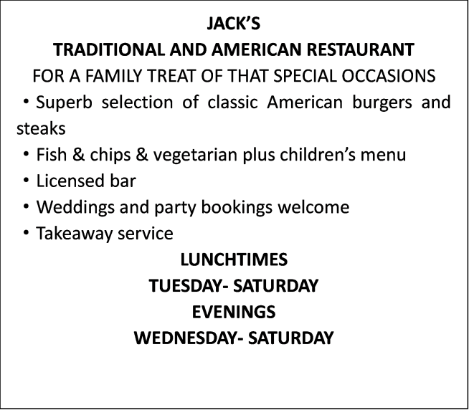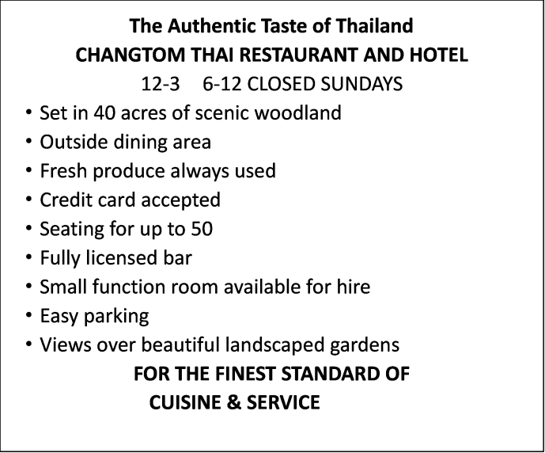
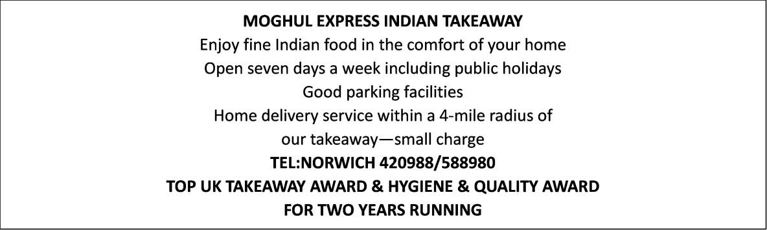
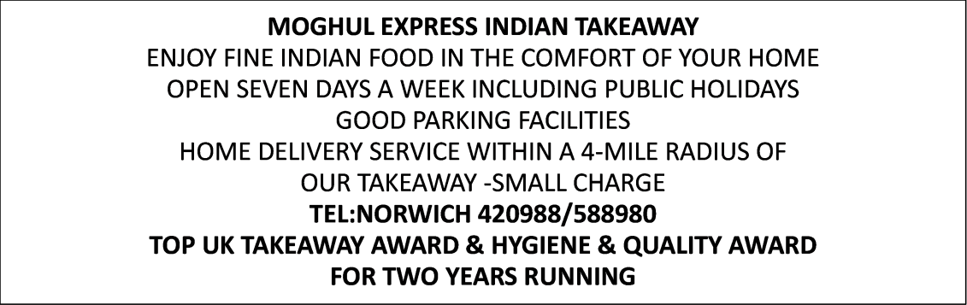
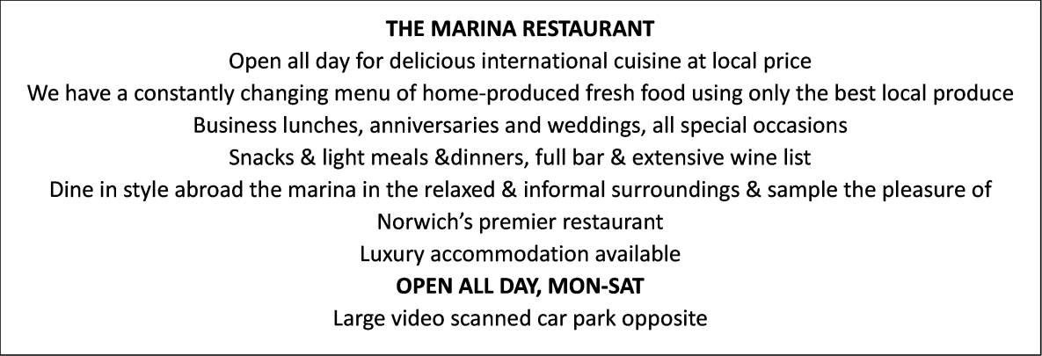
36. In which restaurant can you have a meal with peaceful country surroundings?
A. CHANGTOM THAI RESTAURANT AND HOTEL
B. JACK’S TRADITIONAL AND AMERICAN RESTAURANT
C. MOGHUL EXPRESS INDIAN TAKEAWAY
D. THE MARINA RESTAURANT
37. It can be concluded that _______.
A. you can enjoy the freshest local produce in CHANGTOM THAI RESTAURANT AND HOTEL
B. JACK’S TRADITIONAL AND AMERICAN RESTAURANT satisfies all different tastes
C. you can have your order delivered in MOGHUL EXPRESS INDIAN TAKEAWAY for an extra fee
D. THE MARINA RESTAURANT provides the best accommodation of the four restaurants
【答案】36. A 37. C
【解析】
本文是一篇应用文，介绍了四家有特色的餐馆。
【36题详解】
细节理解题。根据第二则广告中的信息可知，CHANGTOM 泰餐馆坐落在一个风景秀丽的林地，拥有户外餐厅，可以欣赏到园林式的花园，想在一个安静的乡村环境下用餐应该选择这里，故A项正确。
【37题详解】
推理判断题。根据第三则广告中的“our takeaway—small charge”可知，可以通过支付外卖小费在MOGHUL EXPRESS 印度外卖店点餐，故C项正确。
B
Regulating a complex new technology is hard, particularly if it is evolving rapidly. With autonomous vehicles(AVs) just around the corner, what can policymakers do to ensure that they arrive safely and smoothly and deliver on their promise?
The immediate goal is to make sure that AVs are safe without preventing innovation. In America, experimental AVs are allowed on the road in many states as long as the companies operating them accept responsibility. Chris Urmson of Aurora says American regulators have got things right, working closely with AV firms and issuing guidelines rather than strict rules that might prevent the progress of the industry. “It’s important that we don’t jump to regulation before we actually have something to regulate.” he says.
On the other hand, Singapore’s government has taken the most hands-on approach to preparing for AVs, says Karl Iagnemma of Nutonomy, an AV startup that has tested vehicles in the city-state. For example, it has introduced a “driving test” that AVs must pass before they can go on the road. This does not guarantee safety but sets a minimum standard.
Elsewhere, regulators have permitted limited testing on public roads but want to see more evidence that the vehicles are safe before going further, says Takao Asami of the Renault issan-Mitsubishi alliance(联盟). “Simple accumulation of mileage(里程) will never prove that the vehicle is safe.” he says. Instead, regulators are talking to car makers and technology firms to develop new safety standards. Marten Levenstam, head of product strategy at Volvo, compares the process to that of developing a new drug. First, you show in the laboratory that it might work; then you run clinical trials in which you carefully test its safety and efficiency; and if they are successful, you ask for regulatory approval to make the drug generally available. Similarly, autonomous cars are currently at the clinical-trial stage, without final approval as yet. It is not possible to prove that a new drug is entirely safe, but the risk is worth taking because of the benefits the drug provides. It will be the same for AVs, he suggests. After all, nowadays human-driven vehicles are hardly risk-free.
38. In Chris Urmson’s opinion, _______.
A. strict rules are necessary in the progress of AVs
B. we must regulate AVs before problems occur
C. governments should take approaches to preparing for AVs
D. regulators had better cooperate with AV firms and issue guidelines
39. How is the process of developing new safety standards of AVs explained in the last paragraph?
A. By giving examples B. By making comparisons
C. By analyzing cause and effects D. By listing statistics
40. What is Marten Levenstam’s attitude towards AVs?
A. Positive. B. Negative.
C. Neutral. D. Doubtful.
【答案】38. D 39. B 40. A
【解析】
【分析】
本文是一篇说明文，介绍了随着无人驾驶汽车即将问世，监管机构需要与AV 公司密切合作，发布指导方针以确保无人驾驶汽车安全到达目的地，沃尔沃产品战略主管Marten Levenstam将制定新的安全标准的过程比作研发一种新药的过程，并对此持积极的态度。
【38题详解】
细节理解题。根据第二段中的“Chris Urmson of Aurora says American regulators have got things right, working closely with AV firms and issuing guidelines rather than strict rules that might prevent the progress of the industry.”可知，Urmson认为美国监管机构做得很对，他们与AV 公司密切合作，发布指导方针，故D项正确。
【39题详解】
细节理解题。根据最后一段中的“Instead, regulators are talking to car makers and technology firms to develop new safety standards. Marten Levenstam, head of product strategy at Volvo, compares the process to that of developing a new drug.”可知，沃尔沃产品战略主管Marten Levenstam将制定新的安全标准的过程比作研发一种新药的过程，故B项正确。
【40题详解】
观点态度题。根据最后一段中的“It is not possible to prove that a new drug is entirely safe, but the risk is worth taking because of the benefits the drug provides. It will be the same for AVs, he suggests.”可知，要证明一种新药完全安全是不可能的，但由于它所提供的好处，这种风险是值得的，无人驾驶技术也是一样，由此可知，Marten Levenstam是无人驾驶技术的态度是积极的，故A项正确。
【点睛】观点态度的难度通常较大，需要通过人物所说的话来揣摩其观点态度，例如本篇第3题，根据最后一段中Marten Levenstam所说的话“It is not possible to prove that a new drug is entirely safe, but the risk is worth taking because of the benefits the drug provides. It will be the same for AVs, he suggests.”可知，要证明一种新药完全安全是不可能的，但由于它所提供的好处，这种风险是值得的，无人驾驶技术也是一样，由此可知，Marten Levenstam对无人驾驶技术的态度是积极的。
C
Cooperation at work is generally seen as a good thing. The latest survey by the Financial Times of what employers want from MBA graduates found that the ability to work with a wide variety of people was what managers wanted most. But managers always have to balance the benefits of teamwork, which help ensure that everyone is working towards the same goal, with the dangers of “groupthink” when critics are reluctant to point out a plan’s drawbacks for fear of being kept out of the group. The disastrous Bay of Pigs invasion of Cuba in 1961 was a classic case of groupthink. Skeptics were reluctant to challenge John F. Kennedy, the newly elected American president.
Modern communication methods mean that cooperation is more frequent. Workers are constantly in touch with each other via e-mail messaging groups or mobile calls. But does that improve, or lower performance? A new study by three American academics, tried to answer this question. They set a logical problem (designing the shortest route for a travelling salesman visiting various cities). Three groups were involved: one where subjects acted independently; another where they saw the solutions posted by team members at every stage; and a third where they were kept informed of each other’s views only intermittently.
The survey found that members of the individualist group reached the premier solution more often than the constant cooperators but had a poorer average result. The intermittent cooperators found the right result as often as the individualists, and got a better average solution. When it comes to ideal generation, giving people a bit of space to a solution seems to be a good idea. Occasional cooperation can be a big help: most people have benefited from a colleague’s brainwave or (just as often) wise advice to avoid a particular course of action.
Further clues come from a book, Superminds, by Thomas Malone of the Massachusetts Institute of Technology. He says that three factors determine the collective intelligence of cooperating groups: social intelligence (how good people were at rating the emotional states of others); the extent to which members took part equally in conversation (the more equal, the better); and the cooperation of women in the group (the higher, the better). Groups ranked highly in these areas cooperated far better than others.
In short, cooperation may be a useful tool but it doesn’t work in every situation.
41. The author cites the example of The Bay of Pigs invasion of Cuba in paragraph 1 to _______.
A. prove that team players are skilled at communication
B. show that teamwork cannot always be beneficial
C. prove that critics are unwilling to challenge anybody
D. show the danger of groupthink is not very serious
42. The underlined phrase “the intermittent cooperators” in paragraph 3 refers to _______.
A. those who do not cooperate but reach the best solution
B. those who are seldom informed of other’s views
C. those who cooperate with others occasionally
D. the constant cooperators with a poor average result
43. Which of the following factors makes a team cooperate better?
A. Group members cooperating all the time.
B. Group members in a good emotional state.
C. Equal distribution of men and women.
D. Equal participation in the communication.
44. Which can be the best title of the passage?
A. When Teamwork Works B. What Teamwork Is About
C. How Teamwork Operates D. A Useful Tool: Cooperation
【答案】41. B 42. C 43. D 44. A
【解析】
【分析】
本文是一篇说明文，介绍了团队合作是一种有用的工具，但并非在所有情况下都有用。
【41题详解】
推理判断题。根据第一段中的“But managers always have to balance the benefits of teamwork, which help ensure that everyone is working towards the same goal, with the dangers of “groupthink” when critics are reluctant to point out a plan’s drawbacks for fear of being kept out of the group. The disastrous Bay of Pigs invasion of Cuba in 1961 was a classic case of groupthink.”可知，经理们总是在团队合作的好处和群体思维的危险之间取得平衡，1961年灾难性的猪湾入侵古巴就是群体思维的危险性的经典案例，作者举这个例子就是为了证明团队合作不总是有益的，故B项正确。
【42题详解】
词义猜测题。根据画线词前的“The survey found that members of the individualist group reached the premier solution more often than the constant cooperators but had a poorer average result.”可知，调查发现个人主义小组的成员比经常合作的小组成员更容易达成首要解决方案，此处是说偶尔性的合作者与个人主义者一样经常能找到正确的结果，并得到更好的平衡解，由此可知画线词词义为“偶尔合作的人”，故C项正确。
【43题详解】
细节理解题。根据最后一段中的“the extent to which members took part equally in conversation (the more equal, the better)”可知，平等地参与交流能够让团队合作得更好，故D项正确。
【44题详解】
主旨大意题。根据文章内容，特别是最后一段中的“In short, cooperation may be a useful tool but it doesn’t work in every situation.”可知，团队合作并非在所有情况下都有用，故A项正确。
【点睛】主旨大意题的难度较大，需要紧紧地抓住文章的主题句，如果文章第一段没有明显的主题句，那么最后一段带有总结性的句子就是主题句，例如本篇第4题，最后一段中的“In short”是明显的总结性的词语，根据“In short, cooperation may be a useful tool but it doesn’t work in every situation.”可知，本文介绍了团队合作是一种有用的工具，但并非在所有情况下都有用。
D
An introduction to this book is as superfluous as a candle in front of a powerful searchlight. But a convention of publishing seems to require that the candle should be there, and I am proud to be the one to hold it. About ten years ago I picked up from the pile of new books on my desk a copy of Sons and Lovers by a man of whom I had never heard, and I started to race through it with the immoral speed of the professional reviewer. But after a page or two I found myself reading, really reading. Here was—here is—a masterpiece in which every sentence counts, a book packed with significant thought and beautiful, arresting phrases, the work of a remarkable genius whose gifts are more richly various than those of any other young English novelist.
To appreciate the rich variety of Mr. Lawrence we must read his later novels and his volumes of poetry. But Sons and Lovers reveals the range of his power. Here are combined and blended(混合的) sort of “realism” and almost lyric(抒情的) imagery and rhythm. The speech of the people is that of daily life and the things that happen to them are normal adventures and accidents; they fall in love, marry, work, fail, succeed, and die. But of their deeper emotions and of the relations of these little human beings to the earth and to the stars, Mr. Lawrence makes something near to poetry and prose(散文) without violating its proper “other harmony.”
Take the marvellous paragraph on next to the last page of Sons and Lovers (Mr. Lawrence depends so little on plot in the ordinary sense of the word that it is perfectly fair to read the end of his book first):
Where was he? One tiny upright speck of flesh, less than an ear of wheat lost in the field. He could not bear it. On every side the immense dark silence seemed pressing him, so tiny a spark, into extinction, and yet, almost nothing, he could not be extinct. Night, in which everything was lost, went reaching out, beyond stars and sun, stars and sun, a few bright grains, went spinning round for terror, and holding each other in embrace, there in the darkness that outpassed them all, and left them tiny and daunted(气馁). So much, and himself, infinitesimal, at the core a nothingness, and yet not nothing.
Such glorious writing lifts the book far above a novel which is merely a story. I beg the reader to attend to every line of it and not to miss a single one of the many sentences that await and surprise you. Some are enthusiastic and impressive, like the paragraph above; others are keen, “realistic” observations of things and people. In one of his books Mr. Lawrence makes a character say, or think, that life is “mixed.” That indicates his philosophy and his method. He blends the accurately literal and trivial(琐碎的) with the extremely poetic.
To find a similar blending of tiny daily detail and wide imaginative vision, we must go back to two older novelists, Hardy and Meredith. I do not mean that Mr. Lawrence derives(源于) immediately from them or, indeed, that he is clearly the disciple(弟子) of any master. I do feel simply that he is of the elder stature(名望) of Hardy and Meredith, and I know of no other young novelist who is quite worthy of their company. When I first tried to express this comparison, this connection, I was contradicted by a fellow-critic, who pointed out that Meredith and Hardy are entirely unlike each other and that therefore Mr. Lawrence cannot resemble both. To be sure, nothing is more hateful than forced comparisons, nothing more boring than to discover parallels between one work of art and another. An artist’s mastery consists in his difference from other masters. But to refer a young man of genius to an older one, at the same time pronouncing his independence and originality, is a fair, if not very superior, method of praising him.
45. The underlined word “superfluous” in paragraph 1 is closest in meaning to _______.
A. meaningful B. unnecessary
C. fundamental D. unbelievable
46. What is typical of Lawrence’s works?
A. They equally reveal his genius power.
B. They contain lots of great lyric poetry.
C. They present some real living situations.
D. They focus on relations between humans.
47. What does the author want to illustrate by including one paragraph from Sons and Lovers?
A. The plot of the novel has little to do with daily life.
B. It is wise to read Lawrence’s books from the end.
C. Lawrence is capable of telling good stories.
D. The language in Lawrence’s books is elegant.
48. Who were Hardy and Meredith?
A. They taught Lawrence literature when he was young.
B. They were the realistic novelists of Lawrence’s time.
C. They were novelists who resemble each other in writing.
D. They were novelists combining details with imagination.
49. According to the author, what does an artist’s mastery mean?
A. He must have personal diversity.
B. He must have the critical spirits.
C. He must be happy to be compared.
D. He must be a man of genius.
50. What is the author’s purpose in writing the passage?
A. To introduce Lawrence’s novel Sons and Lovers.
B. To show his experiences of reading classics.
C. To analyze Lawrence’s writing characteristics.
D. To compare the styles of different novelists.
【答案】45. B 46. C 47. D 48. D 49. A 50. C
【解析】
【分析】
本文是一篇说明文，以劳伦斯的作品《儿子和爱人》为例介绍了劳伦斯的作品的特点——在不破坏诗歌和散文的和谐的前提下，使其更接近诗歌和散文，内容还展示了一些真实的生活场景，同时作者还指出一个艺术家的才能在于具有个人的多样性。
【45题详解】
词义猜测题。根据画线词后的“as a candle in front of a powerful searchlight.”可知，一本书的序言就像强光探照灯前的蜡烛一样多余，由此可知画线词词义为“没必要的”，故B项正确。
【46题详解】
细节理解题。根据第二段中的“The speech of the people is that of daily life and the things that happen to them are normal adventures and accidents”可知，劳伦斯作品中人物的语言是日常生活用语，发生在她们身上的也都是日常生活中的经历，也就是展示了一些真实的生活场景，故C项正确。
【47题详解】
推理判断题。根据第二段中的“Mr. Lawrence makes something near to poetry and prose(散文) without violating its proper “other harmony.””可知，劳伦斯在不破坏诗歌和散文的和谐的前提下，使他的作品更接近诗歌和散文，语言很优美，作者举《儿子和爱人》中的一段为例就是为了证明这一点，故D项正确。
【48题详解】
推理判断题。根据最后一段中的“To find a similar blending of tiny daily detail and wide imaginative vision, we must go back to two older novelists, Hardy and Meredith.”可知，为了找到将生活中的细节和想象结合起来的作品，我们必须求助于两位更年长的小说家Hardy和 Meredith，由此可知他俩都是将生活中的细节和想象结合起来的小说家，故D项正确。
【49题详解】
细节理解题。根据最后一段中的“An artist’s mastery consists in his difference from other masters.”可知，作者认为一个艺术家的才能在于他必须与其他的大师的不同，也就是具有个人的多样性，故A项正确。
【50题详解】
作者意图题。通读全文可知，这篇文章以劳伦斯的作品《儿子和爱人》为例介绍了劳伦斯的作品的特点——在不破坏诗歌和散文的和谐的前提下，使其更接近诗歌和散文，内容还展示了一些真实的生活场景，故C项正确。
【点睛】作者意图题的难度较大，需要根据文章主旨来把握作者意图，例如本篇第6题，通读全文可知，这篇文章以劳伦斯的作品《儿子和爱人》为例介绍了劳伦斯的作品的特点——在不破坏诗歌和散文的和谐的前提下，使其更接近诗歌和散文，同时他的作品还展示了一些真实的生活场景。
第Ⅱ卷 (两部分 共35分)
第四部分 任务型阅读 (共10小题；每小题1分，满分10分)
请认真阅读下列短文，并根据所读内容在文章后表格中的空格里填入一个最恰当的单词。
注意：每个空格只填1个单词。请将答案写在答题卡上相应题号的横线上。
The changes facing fast-food companies
Fast food was once thought to be recession-proof. When consumers need to cut spending, cheap meals like Big Macs and Whoppers become even more attractive. As a result, fast-food chains have survived the recession better than their more expensive competitors. In 2009 sales at full-service restaurants in America fell by more than 6%, but total sales remained about the same at fast-food chains. In some markets, such as Japan, France and Britain, total spending on fast food increased.
But in this ongoing recession(萧条), which is more severe, not all fast-food companies have been as fortunate. Many, such as Burger King, have seen sales fall. In the recession, while some people trade down to fast food, many others eat at home more frequently to save money. Smaller fast-food chains in America, such as Jack in the Box and Carl’s Jr., have been hit particularly hard in this downturn because they cut back spending on advertising.
In face of such challenges, some fast-food companies have sacrificed their own profits by trying to give customers better value. During the recession companies set prices low, hoping to tempt more customers through the door. But in many cases that strategy doesn’t work. Some companies are rethinking their strategies. KFC has launched a chicken sandwich that costs around $5 to attract consumers away from $1 specials.
Companies are also trying to get customers to buy new and more items, including drinks. McDonald’s started selling better coffee as a challenge to Starbucks. Its “McCafe” line now accounts for an estimated 6% of sales in America. As fast-food companies shift from “super size” to “more buys”, they need to keep customer traffic high throughout the day. Many see breakfast as a big opportunity, and not just for fatty food. McDonald’s has started selling porridge in America, because the profits can be high.
But what about those growing waistlines? So far, fast-food firms have cleverly avoided government regulation. By providing options like salads and low-calorie sandwiches, they have at least given the impression of doing something about helping to fight obesity(肥胖). These offerings don’t necessarily lead to profit loss, as they can broaden the appeal of stores to groups of diners that include some people who don’t want to eat a burger.
But calls for tougher government regulation never wear down. This year Congress passed America’s health-reform bill, which requires restaurant chains with 20 or more stores to put the calorie-content of items they serve to the menu. And the recent proposal by a county in California to ban McDonald’s from including toys in its high-calorie “Happy Meals”, because law makers believe it attracts children to unhealthy food, suggests that fast-food companies will have to continue trying something new.
The changes facing fast-food companies
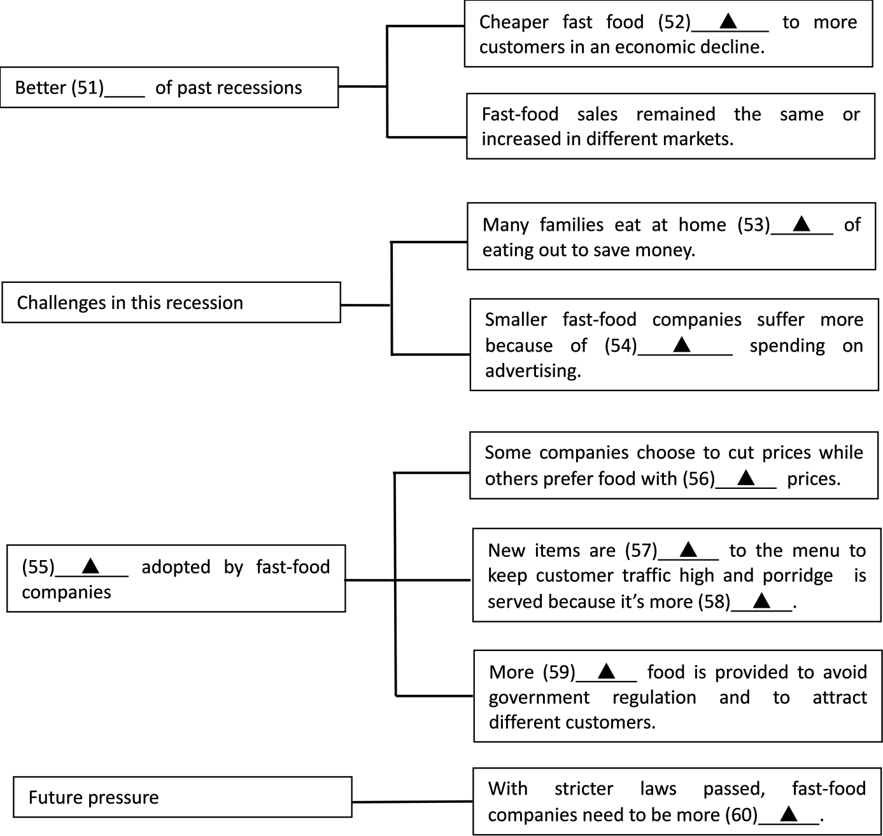
51. ______________________
52. ______________________
53. ______________________
54. ______________________
55. ______________________
56. ______________________
57. ______________________
58. ______________________
59. ______________________
60. ______________________
【答案】51. survivors/competitors/businesses/companies
52. appeals
53. instead
54. decreased/reduced/less
55. Strategies/Measures/Approaches/Solutions/Ways
56. high/higher
57. added 58. profitable
59. healthy/healthier
60. creative/innovative/flexible/adaptable
【解析】
本文是一篇说明文，介绍了快餐公司在经济衰退中面临的挑战以及他们所采取的对策，同时指出随着更严格的食品法的实施，快餐公司应变得更有创造性。
【51题详解】
考查名词。根据第一段中的“As a result, fast-food chains have survived the recession better than their more expensive competitors.”快餐连锁店在经济衰退中比那些价格更高的竞争对手生存得更好，他们成为了更好的幸存者、竞争者、企业或公司，故填survivors/competitors/businesses/companies。
【52题详解】
考查动词。根据第一段中的“When consumers need to cut spending, cheap meals like Big Macs and Whoppers become even more attractive.”可知，在经济衰退期间，便宜的快餐更吸引消费者，appeal to表示“吸引”，故填appeals。
【53题详解】
考查固定搭配。根据第二段中的“In the recession, while some people trade down to fast food, many others eat at home more frequently to save money.”可知，在经济衰退期间，很多人为了省钱选择在家吃饭而不是出去吃，insead of表示“代替、而不是”，故填instead。
【54题详解】
考查形容词。根据第二段中的“Smaller fast-food chains in America, such as Jack in the Box and Carl’s Jr., have been hit particularly hard in this downturn because they cut back spending on advertising. ”可知，小型的快餐公司在经济衰退中受到更沉重的打击是因为它们削减了广告开支，修饰名词spending用形容词，表示“更少的、被削减的”，故填decreased/reduced/less。
【55题详解】
考查名词。第三、四段介绍了快餐公司为了应对这些挑战所采取的对策，故填Strategies/Measures/Approaches/Solutions/Ways。
【56题详解】
考查形容词。根据第三段中的“Some companies are rethinking their strategies. KFC has launched a chicken sandwich that costs around $5 to attract consumers away from $1 specials.”可知，一些快餐公司重新考虑他们的战略，像肯德基就推出了一款售价5,美元的鸡肉三明治以吸引消费者放弃1美元的特价，与1美元的特价相比，他们的商品的价格是较高的，故填high/higher。
【57题详解】
考查名词。倒数第三段举麦当劳卖咖啡和早餐粥为例证明快餐公司的食谱中增加一些新食品来保持较高的客流量，故填added。
【58题详解】
考查形容词。根据倒数第三段中的“McDonald’s has started selling porridge in America, because the profits can be high.”可知，麦当劳卖早餐粥是因为它的利润更大，此处用形容词作表语，故填profitable。
【59题详解】
考查形容词。根据倒数第二段中的“So far, fast-food firms have cleverly avoided government regulation. By providing options like salads and low-calorie sandwiches, they have at least given the impression of doing something about helping to fight obesity”可知，快餐公司提供像沙拉和低卡路里的三明治这样健康的食物来避开政府监管，故填healthy/healthier。
【60题详解】
考查形容词。根据最后一段中的“suggests that fast-food companies will have to continue trying something new.”可知，随着更为严格的食品法的通过，快餐公司需要继续尝试新的东西，更有创造性、更灵活，此处缺少形容词作表语，故填creative/innovative/flexible/adaptable。
第五部分 书面表达 (满分25分)
61.请阅读下面短文，并按照要求用英语写一篇150词左右的文章。
The hardworking and never-give-up attitude of Malaysian badminton star Lee Chong Wei has won many people’s hearts.
The 36-year-old player is already a veteran of the badminton world. Despite this, he doesn’t want to call it a day. At the moment, nose cancer is keeping him out of the game.
At a press conference earlier this month, Lee said that he hopes to return to badminton next year and to compete in his fifth Olympic Games held in Tokyo in 2020. “It’s going to be tough to fight for the gold medal, but I will try my very best because it’s always my dream,” he said. Although Lee is one of the world’s greatest players, he has never won a badminton world championship. So if health permits, he will continue to compete because he wants an Olympic gold. Besides his great determination, his other drive is his passion for the sport. “One of the most important things in life to him is badminton,” Lee’s coach Misbun Sodik told the New Straits Times.
After two months of cancer treatment that caused eating and sleeping problems, recently Lee began a little training.
【写作内容】
1. 用约30个单词概述上述信息的主要内容；
2. 综合上述信息，用约120个单词谈一谈“热情对于一个人事业成功的重要性”及其理由。
【写作要求】
1. 写作过程中不能直接引用原文语句；
2. 作文中不能出现真实姓名和学校名称；
3. 不必写标题。
【评分标准】
内容完整，语言规范，语篇连贯，词数适当。
_____________________________________________________________________________________________________________________________________________________________________________________________________________________________________________________________________________________________________________________________________________________________________________________________________________________________________________________________________________________________________________________________________________________
【答案】The 36-year-old badminton player, Lee Chong Wei, is admired by many people. Owing to his passion for badminton, he is still determined to compete for an Olympic gold medal despite nose cancer.
As is known to all, passion is an essential factor to the career we are devoted to. Without passion, we tend to easily lose heart when faced with challenges or failures. However, if we are extremely enthusiastic about what we are doing, we will become more strong-minded, sparing no effort to overcome difficulties. In addition, when we are determined to achieve something we are interested in, we will no doubt try any method that may lead us to success, which surely will help to explore our potentials and increase our abilities. Besides, it is believed that our passion for the work can make our working environment more friendly, thus promoting our efficiency as well as improving our health condition.
Since being passionate is of such great significance to our career, we should be serious when we choose jobs, and try to do what we are fond of.
【解析】
【分析】
本题考查读写任务，要求用约30词写一个概要，并用约120个单词谈一谈“热情对于一个人事业成功的重要性”及其理由。
【详解】第1步：根据提示可知，本文要求用约30词写一篇概要，并用约120个单词谈一谈“热情对于一个人事业成功的重要性”及其理由。时态应为一般现在时。
第2步：根据写作要求，确定关键词（组），如：admire（钦佩），passion（热情），determined（有决心的），essential（重要的），failure（失败），challenge（挑战），overcome（克服），efficiency（效率），significance（意义）及promote（提升）等。
第3步：根据提示及关键词（组）进行遣词造句，注意该要的词数要求、主谓一致和时态问题。
第4步：连句成文，注意使用恰当的连词进行句子之间的衔接与过渡，书写一定要规范清晰，保持卷面的整洁美观。
本文内容完整，层次分明，结构紧凑，表达准确。另外全文中没有中国式英语的句式，显示了很高的驾驭英语的能力。
【点睛】范文语言地道，语篇连贯，词数适当。作者在范文中使用了较多高级词汇和句式，高级词汇有be devoted to（献身于），Owing to（由于），lose heart (灰心)，be faced with（面对），enthusiastic about（对……有热情的），fond of（喜欢）以及lead to（导致），而且还使用了非限定性定语从句“As is known to all, passion is an essential factor to the career we are devoted to.”及“In addition, when we are determined to achieve something we are interested in, we will no doubt try any method that may lead us to success, which surely will help to explore our potentials and increase our abilities.”， 宾语从句和非谓语动词“However, if we are extremely enthusiastic about what we are doing, we will become more strong-minded, sparing no effort to overcome difficulties.”，状语从句“Since being passionate is of such great significance to our career, we should be serious when we choose jobs, and try to do what we are fond of.”，形式主语“Besides, it is believed that our passion for the work can make our working environment more friendly, thus promoting our efficiency as well as improving our health condition.”，全文没有语法错误，上下句转换自然流畅。

